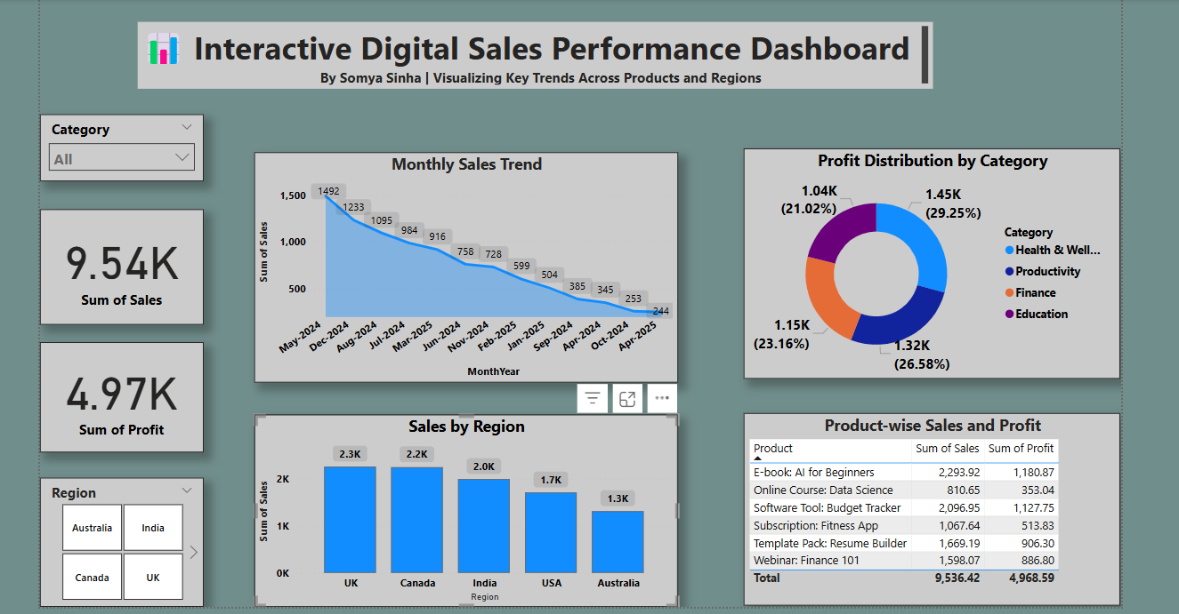

**📊 Insights from the Dashboard:**

**1. Top-Selling Products**

* **E-book: AI for Beginners** leads with ₹2294 in total sales, followed by **Budget Tracker Software Tool** (₹2097) and **Resume Builder Template Pack** (₹1669).
* These three products account for a major share of the revenue, highlighting strong interest in **self-learning** and **productivity-enhancing** tools.

**2. Sales Trend by Month**

* **December 2024** saw the highest sales at ₹1233, followed by a steady decline through **January (₹503)** and **February (₹599)**, ending with a drop to ₹244 in **April**.
* This trend may indicate **seasonal demand spikes**, especially around year-end, and a need to address the sharp dip in Q2.

**3. Sales Distribution by Region**

* The **UK (₹2262)** and **Canada (₹2249)** recorded the highest sales, surpassing India, USA, and Australia.
* Targeted promotions in these regions could further strengthen market presence and drive sales even higher.

**4. Category Revenue Contribution**

* **Health & Wellness** leads with ₹2732, followed by **Productivity (₹2444)** and **Finance (₹2277)**.
* The strong performance of these categories suggests a growing focus on **personal development**, **efficiency**, and **financial awareness** among buyers.